Preparing and Using a Standard Solution

# *Aims*

The main aim of this experiment is to give you the opportunity to practice some techniques used in volumetric analysis. You will:

* make up a standard solution of ethanedioic acid
* use this solution to perform a titration with the sodium hydroxide solution provided
* use your knowledge of moles and concentrations to calculate the concentration of the sodium hydroxide solution
* consider apparatus and procedural errors.

You are provided with:

* ethanedioic acid crystals (C2H2O4.2H2O)
* a solution of sodium hydroxide of unknown concentration
* phenolpthalein indicator (which is colourless in acid and pink in alkali)

**Safety Notes**

Harmful 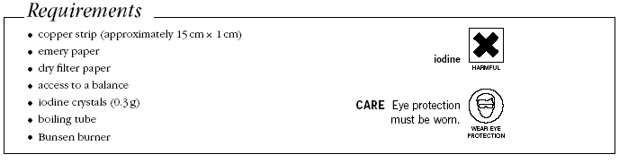

Irritant: ethanedioic acid, sodium hydroxide

**Making up the standard ethanedioic acid solution**

1. Using a weighing boat, weigh out between 0.70g and 0.90g of ethanedioic acid and record the mass of the boat plus acid
2. Transfer it to a 250 cm3 beaker, reweigh the weighing boat and record its mass.
3. Dissolve the solid in no more than 100 cm3 distilled water, and transfer the solution plus washings to a 250 cm3 volumetric flask.
4. Make up to the mark with distilled water, adding the water drop wise up to the mark.
5. Insert the stopper and invert the flask several times so that the solution in thoroughly mixed.

***Results***

Mass of weighing boat + ethanedioic acid =

Mass of weighing boat =

Mass of ethanedioic acid =

***To calculate the concentration of ethanedioic acid***

* Mass of ethanedioic acid in 250 cm3 solution =
* Mr of ethanedioic acid (C2H2O4.2H2O) =
* Number of moles of ethanedioic acid in 250 cm3 solution =
* Concentration of ethanedioic acid (mol dm-3) =

**A titration to find the concentration of a sodium hydroxide solution**

1. Transfer the solution of the ethanedioic acid to a beaker and label it.
2. Set up a burette and fill it with the acid solution.
3. Use a pipette and pipette filler to transfer 25.0 cm3 of the sodium hydroxide solution to a conical flask
4. Add three drops of phenolphthalein and add the acid from the burette until the indicator changes colour from pink to colourless. Make sure you swirl the flask after every addition of acid.
5. Repeat your titration accurately, adding the acid drop-wise near the end point.
6. Continue performing accurate titrations until you have concordant results (i.e. at least two titres within 0.1 cm3)
7. Record all your results in the results table.

***Titration Results***

|  |  |  |  |  |
| --- | --- | --- | --- | --- |
|  | Rough | Accurate | | |
| 1 | 2 | 3 |
| Final burette reading /cm3 |  |  |  |  |
| Initial burette reading /cm3 |  |  |  |  |
| Titre / cm3 |  |  |  |  |

Place a tick under the concordant titres and use them to calculate the average titre.

**Summary**

On average 25.O cm3 of sodium hydroxide required .............. cm3 of ethanedioic acid

***To calculate the concentration of sodium hydroxide***

The equation for the neutralisation reaction is:

H2C2O4 + 2NaOH → Na2C2O4 + 2H2O

* Use the mean titre and the concentration of ethanedioic acid found previously to calculate the number of moles of ethanedioic acid used.
* Use the balanced equation to calculate the number of moles of sodium hydroxide in 25cm3
* Calculate the concentration (in mol dm-3) of the sodium hydroxide solution.

# *Evaluation*

1. Assuming the errors for the apparatus used were:

* Balance + 0.01g
* Volumetric flask + 0.3 cm3
* Burette + 0.05 cm3
* Pipette + 0.06 cm3

calculate the percentage error in using each piece of apparatus, and the overall apparatus error.

1. Suggest any other sources of error in this experiment.