**Student Worksheet**

**Practical 6: Combustion of the alkanes**

**Procedure**

**General combustion:**

1. Place a small amount of the alkane on a deflagrating spoon using a pipette
2. Place it in a Bunsen burner to set alight. Observe the colour and sootiness of the flame.
3. Place a small beaker of water over the flame to check its sootiness.

**Complete combustion:**

1. Set up the apparatus as shown in the diagram. You may use a burner instead of a Bunsen burner.
2. Leave the experiment running for approximately 10 minutes.
3. Record your observations in the cold test tube and the limewater.

**Incomplete combustion:**

1. Light a Bunsen burner on a low flame.
2. Adjust the air hole to a yellow flame. Place a small beaker of cold water over the flame to check for sootiness.
3. Repeat steps 7 and 8 with the air hole open.

 

Highly Harmful

flammable



Irritant

**Safety**

* Wear eye protection.
* Alkanes are highly flammable and harmful/irritant.

**From the examiner…**

* It is essential to know the general formulae of alkanes.
* Check that the number of carbons and the number of hydrogen’s are the same on each side of your equation.
* When balancing combustion reactions always balance in this order: C,H,O.

**Analysis of results**

* Present your results in a suitable format.

**Diagram**

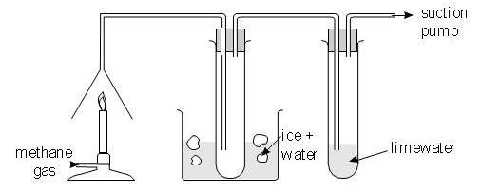

**Objective**

* To understand that shorter alkanes burn cleaner
* To know the combustion products

**Questions**

1. Is there a pattern between the number of carbons and the colour / sootiness of a flame?
2. What are the products of combustion? Write a balanced equation for the combustion of hexane.
3. What does opening the air hole allow more of?
4. What effect does this have on the colour of the flame?
5. Explain why a flame appears yellow?

**Equipment/materials**

* Heavy paraffin oil (alkane)
* Butane
* Pentane
* Hexane
* Deflagrating spoons
* Tin lids
* Bunsen burner
* Heat-proof mat
* Combustion apparatus
* Limewater